Name: ___________________________ The Crusades
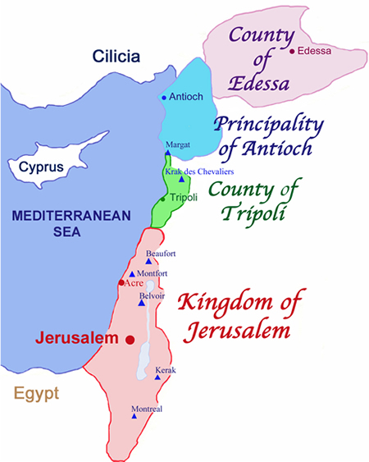
By 900 CE the known world was split into three: Western Europe, or Christendom; the Byzantine east, or Orthodox Church; and the Levant, controlled by Islam.
Arabic science, mathematics, medicine and technology reached Europe through the spread of Islam.
Conflict for control within Spain saw clashes between Muslims and Christians. This hardened Christians against Muslims, who expected Muslims (and Jews) to forgo their religions and choose Christianity.
Christianity and Islam were to clash on a larger scale in 1095 CE and a series of wars commenced that lasted about 200 years. Up until 1095 CE, Muslims had allowed Christian pilgrims to visit Jerusalem. From that date onwards, Christians were forbidden to enter the city and faced execution if they disobeyed. As a result, Pope Urban II called on Christians to fight to restore Christian control of these holy places. The Christians who answered this call became known as ‘Crusaders’.
The Pope argued that non-believers should not have control of sacred religious sites, Jerusalem considered to be the spiritual centre of Christendom. Pilgrimages to Jerusalem were considered an important act of penance.
Crusaders came from all levels of society, answering the call out of religious faith. Knights saw it as a means to try out their fighting skills; peasants saw it as a way to escape ordinary life and seek adventure. An opportunity to access more lands was an appeal to the nobles in a time when agricultural techniques were improving and competition for expansion was growing.
The practice of inheritance by the eldest son meant that younger sons were naturally looking for new lands to become their own lord.
The First Crusade, 1096 – 1099, was planned to recapture Jerusalem and establish a Christian holy land., establishing the four states of Edessa, Antioch, Tripoli and Jerusalem.
By 1144, Edessa fell to Islamic forces with great alarm in Europe. Pope Eugene III called for a Second Crusade, 1145 – 1149, which ended in failure.
In 1171, the Muslim General, Saladin, united Egypt and Syria, surrounding the Crusader states. In 1187, Saladin captured Jerusalem and the important city of Acre. The uproar at these events created the Third Crusade. This time armies were raised by King Richard I of England, King Phillip II of France, and the Holy Roman Emperor, Frederick Barbarossa. Acre was recaptured with many of its inhabitants murdered by the Crusaders - it was seen as acceptable to kill pagans and non-believers. Jerusalem could not be recaptured.
Both sides experienced difficulties: the Crusader leaders found it difficult to agree on strategy; Saladin had numerous internal social and political problems that hindered him, such as the divisions within Islam between Sunni and Shi’ite. Muslim tribes would often not cooperate. Eventually, the two sides agreed to let Muslims retain control of Jerusalem on condition that Christian pilgrims could visit the city and its holy sites.
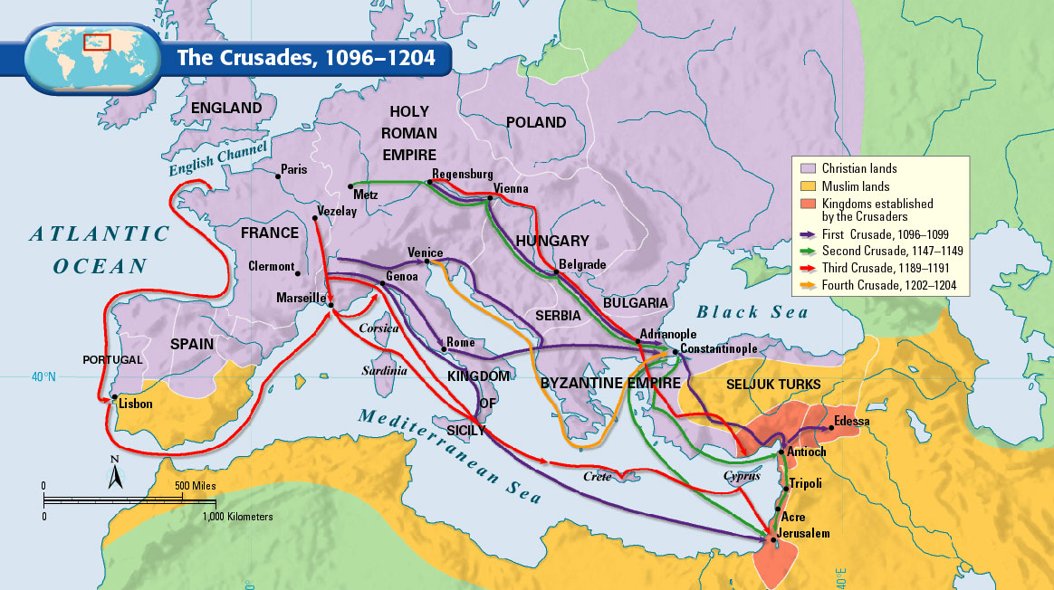

The Crusaders continued to disagree amongst themselves, largely based upon political rivalry and who would have access to important trade routes. A Fourth Crusade occurred between 1202 – 1204, this time to capture the important trade city of Constantinople. Over extended and far away from their supply cities in Europe, the Islamic armies eventually prevailed and Constantinople was lost and the last Christian city, Acre, fell.

